13.71: a) For the totally inelastic collision, the final speed in terms of the initial speed 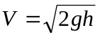 is
to two figures. b) When the steak hits, the pan is 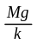 above the new equilibrium position. The ratio 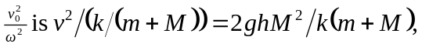 and so the amplitude of oscillation is
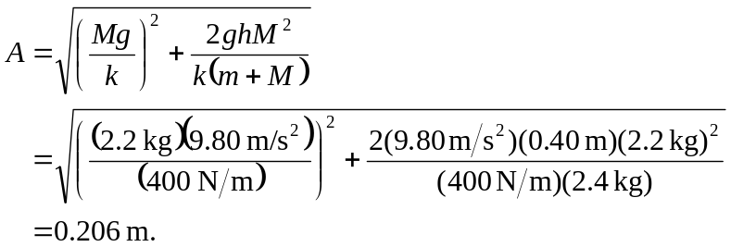

(This avoids the intermediate calculation of the speed.) c) Using the total mass, 